Proposed Implementation Methodology
The following step-wise approach would be carried out for implementation of this project:
Phase-I:
- Survey and Study of Current System and Sites identified by Stakeholders
- Detailed System Design and System Architecture
- Process Flows and Functional Specification Requirements
- Systems Deliverable Plan
Phase-II:
- Deployment and Installation Testing and Production Servers and allied accessories
- Deployment and establishment of Infrastructure
- Deployment and establishment of ICT/Datacenter Infrastructure
- Development of templates and analytical reports
- Customization of off-the-shelf Developed Software System
Phase-III:
- System Tested and Quality Assured
- System Roll Out
- Pilot testing
- Complete Documentation
- Support Service

System Analyst along with Implementation Team Lead would conduct the survey for identification of INPUTs. Also, templates for collection of data against Software development and infrastructure deployment would be developed to be filled out by the council. For this purpose following activities would be performed:
- Consultations would be conducted with the concerned institutions to recommend the sort of information/ data to be placed on the datacenter for attendance operations.
- The sort of technology, ICT Infrastructure and Data Centre Technology for Attendance Management through consultations of stakeholders in the client vicinity would be analyzed for Software Development or Customization of the off-the-shelf application.
- The approval of the HR Department regarding the type and format of turn-key solution would be sort out.
- On completion of phase-I& phase-II following reports/documents would be produced:
- Meta standards and guidelines
- Infrastructure Development Plan
- Data management guidelines
- Technology requirement plan.
- Data Collection template
- Develop Training Plan
- Develop Support Plan
- Develop disaster, recovery, and business and resumption plan. Develop risk assessment and management plan

On the basis of the findings of Phase-I, indicating methodology, approach and techniques to be applied for system requirement and specification document and Functional Specification Requirements to be developed.
On successful customization and pilot testing the focal persons (one from M/s Stepnex and one from client) would sign a go ahead signal for implementation. On successful completion and verification of the client the application would be rolled out and client will issue a completion certificate.
Approach
Due to the nature of the project the major issues in the execution of the project will be coordination with stakeholders, identification of requirements, timely post implementation and proper resource utilization. Whereas overall project management/coordination will be the responsibility of M/S Stepnex Services Pvt. Ltd.
Project Preparation
In this phase a project plan would be prepared and foundations would be laid for successful implementation. At this stage strategic and crucial decision of the project would be made keeping in view the following:
- Define project goals and objectives
- Clarify the scope of project implementation
- Define project schedule, budget plan, and implementation sequence
Business Blueprint
In this phase a project blueprint would be created which will document enterprise’s requirements and establishes how business processes and organizational structure are to be represented in Application. Also original project goals and objectives would be refined and overall project schedule would be revised in this phase, if required.
Realization
In this phase, configure the requirements contained in the Business Blueprint. Baseline configuration (major scope) is followed by final configuration (remaining scope), which can consist of up to four cycles. Other key focal areas of this phase are conducting integration tests and drawing up end user documentation.
Final Preparation
In this phase preparations would be completed, including testing, end user training, system management, and cutover activities. All open issues would be resolved in this phase. At this stage it would be ensured that all the prerequisites for Application to go live have been fulfilled.
Go Live & Support
In this phase project moves from a pre-production environment to the live system. The most important elements include setting up production support, monitoring system transactions, and optimizing overall system performance.
Deliverables
The table below shows the major deliverables in the project.
Sr. No. |  | Title of Deliverables | Indicators
 | 1 | Phase-I:  - Survey and Study of Current Systems and Sites identified by Stakeholders  - Detailed System Design and System Architecture  - Process Flows and Functional Specification Requirements  - Systems Deliverable Plan | SRS document is produced which includes;  Cases used, Description of Attendance System Model, Datacenter Model, Functional requirements, Non-functional requirements, Interface requirement etc.  Flow of data with accuracy and consistency.  Deliverable plan followed.
2 |  | PASE II  System Delivered, Deployed and in production ( according to the agreed deliverables plan)  Following deliverables included but not limited to:  - Deployment and Installation Testing and Production Servers and allied accessories  - Deployment and establishment of Infrastructure  - Deployment and establishment of ICT/Datacenter Infrastructure  - Development of templates and analytical reports  - Customization of off-the-shelf Developed Software System | Plan implementation.  Customization of the off-the-shelf system or development of a new system.  System Roll Out.
3 |  | Phase-III:  - System Tested and Quality Assured  - System Roll Out  - Pilot testing  - Complete Documentation  - Support Service | Checking of the relevant data entered. Quality accessed. Usage Documentation for data entry staff.
 |  | Expiry of Warranty | Guaranteed
Note: Project duration could be managed within the stipulated time frame.
9. Work Plan & Timelines
The below given table entails the deliverables of the project and the expected optimistic time these deliverables are going to take. The project will be LIVE before end of December 2018.
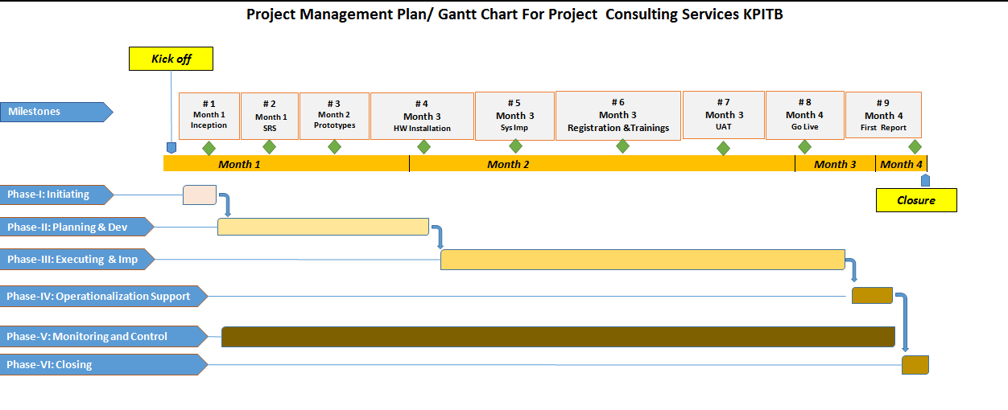

Overall Project Work Plan & Timelines
Task | Deliverables | Months
 |  | 1 | 2 | 3 | 4 | 5
1 | Detailed System Analysis and Preparation of SRS
2 | System Design:
3 | System Development and System Testing
4 | Provision, Installation of Servers
4 | System Implementation and Acceptance:
6 | Staff Training
7 | Supply user manuals with standardized procedure and formatting
8 | Maintenance & Support of Application Software

NOTE: Stepnex Systems implementation team believes that we can save a lot of time through better coordination with the client team.

Project Management & Administration Approach
Majority of projects that fail, do so from a failure in leadership. As a result we have worked diligently to recruit and train top quality service and project managers with significant experience to support their development and infrastructure engagements. The information contained throughout this section will enable client processes that will be used in order to achieve the goals identified above. It is important to note that we have been successful in truly partnering with our clients and other vendors to create solutions that provide the most value for our customers. Our unique ability to partner in a project effort means that our customers obtain an industry leading solution and gain the necessary capabilities to support their ongoing environment.

Communications Management
Project Communications Management includes the client processes required to ensure the timely and appropriate generation, collection, dissemination, storage, and ultimate disposition of project information. Communication provides the critical links between people, ideas, and information that are necessary for success. Everyone involved in the project must be prepared to send and receive communications in the project language or semantics and must understand how the communications they are involved in as individuals affect the project as a whole.
Communications can often times make or break a project. If critical information is not flowing correctly among the project teams, project issues can incur in the successful completion of the project.
For managing the scope of project documentation, we recommend establishing a Project Communications channel that clearly defines the users of information, the frequency of information, project meetings and the content and context of information during the project. In addition, a project central repository will be recommended which facilitates the storage, review and retrieval of all documents related to the project.
Key elements of communications planning will include regular, timely and accurate information regarding the project status, progress, activities, issues, risks, staffing, changes and completion. Strong communications management will keep the executives and project sponsors informed in a timely manner to make appropriate business and project decisions and will coordinate project team and client.

Schedule Management
Project Schedule (Time) Management includes the Client processes required to ensure timely completion of the project. The typical process for deriving scheduled delivery dates follows an established Client procedure. Project Manager will identify phases, sub-phases, activities and tasks within the scope of the project. Schedule work plans will be maintained throughout the life of the project using Microsoft Project. This process will compare actual project progress to plan on defined intervals. Schedule information will be communicated to the client with Issues, and risks with their prioritization through the above described Communications framework.
Issues Management
Problem and Issues occur in every project. Appropriate issue identification, analysis, resolution and escalation processes are vital to ensure that issues have minimal impact upon project objectives, cost and schedule.
Project Issue Management includes the processes concerned with identifying, analyzing, and resolving project issues. Issue management works with the Communications framework to ensure that issues are escalated, resolved and resolution is communicated to appropriate stakeholders in a timely manner. Issues may or may not trigger project risks that could have a serious impact on the project. Early identification and rapid resolution is the key to successful issue management.
Risk Management
Project Risk Management includes the processes concerned with identifying, analyzing, planning and responding to project risk. It includes maximizing the results of positive events and minimizing the consequences of adverse events.
We advocate a proactive risk management approach, meaning the project team has a visible process for managing risks in a measurable and repeatable manner. With proactive risk management, the team assesses risks continuously and uses this information to make decisions in all phases of the project. The team carries risks forward until it resolves them or it handles them if they emerge as problems. At a minimum, a project manager should ascertain and document the level of risk and the effect of that action on the project.
For detail risk management plan refer to Risk Management Plan in Proposed Methodology.
Scope and Change Management
Project Scope Management includes the processes to ensure the project includes all of the work required, and only the work required, to complete the project successfully. Scope Management is primarily concerned with defining and controlling what is or is not included in the project. The major scope management process includes the following:
Initial Scoping- This document specifies the initial scope of the project and defines boundaries of the solution.
Documenting Customer Requirements– A formal document regarding project requirement will be formed after the series of interviews with the client.
Scope verification– formalizing acceptance of the document by the client
One of the key functions of program management is planning and executing the project’s Change Management. Tracking changes to the project’s scope, feature, functionality, documents and technical artifacts provides an essential and effective means to delivering a successful end solution. Change Management process begins with this very documents acceptance where the initial boundaries for the project are specified. The program management team is also responsible for the creation of the Change Control Board (CCB). This team functions as the decision authority for accepting or rejecting changes to the current baseline configuration.
Project Trade Off
The variables in any project are resources (including people and money), schedule (or time), and scope (including features, functionality, the product and its quality). As the team develops a solution, it will inevitably have to make tradeoffs among these project variables. The key to project success is finding the right balance among resources, schedule, and features.

Schedule
Resources
Scope
The major project variables can be viewed as having a triangular relationship. After the team has established the triangle, any change to one of its variables (or sides of the triangle) requires a correction to at least one of the other variables to maintain project balance.

Project Quality Review
To help ensure project success we provide project quality review staff, outside of the core project team of objective analysis. While the project team lives and breathes the solution every day, outside resources bring a new perspective to the team, often recognizing ways to identify and mitigate risk, escalate product issues, or apply the appropriate resources to ensure success.
Project Quality Review will help ensure the key deliverables and criteria of the project are being addressed, documented, managed, and on-target to meet the project’s critical success factors. The progress reviews will be scheduled at the end of the design phase and completion of the development/implementation phase. The separate Internal Quality Audit department on regular intervals to ensure that we live up to its reputation also performs internal Quality Audits.
Acceptance Management
We are keenly interested in the satisfaction and delight of our customer’s and pays close attention to conditions and criteria that will lead to highly satisfied customers and timely adoption and deployment of technology solutions. We understand that high satisfaction is gained through planned excellence and making sure those Client criteria is clearly defined early. We will work with Directorate to establish clear criteria and conditions for success.

